## LinkedList

**package** com.java;

**import** java.util.Iterator;

**import** java.util.LinkedList;

**public** **class** LinkedListPgm {

**public** **static** **void** main(String args[])

{

LinkedList<String> al=**new** LinkedList<String>();

al.add("Anoopa");

al.add("Rohith");

al.add("Jitty");

al.add("Nayana");

Iterator<String> itr=al.iterator();

**while**(itr.hasNext())

{

System.***out***.println(itr.next());

}

}

}

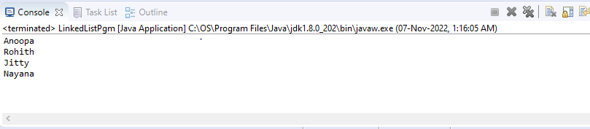

## Stack

**package** com.java;

**import** java.util.Iterator;

**import** java.util.Stack;

**public** **class** Stackpgm {

**public** **static** **void** main(String args[])

{

Stack<String> stack = **new** Stack<String>();

stack.push("January");

stack.push("February");

stack.push("March");

stack.pop();

stack.push("April");

stack.push("May");

stack.pop();

Iterator<String> itr=stack.iterator();

**while**(itr.hasNext())

{

System.***out***.println(itr.next());

}

}

}

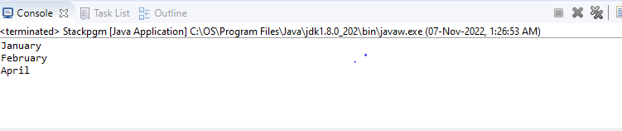

## PriorityQueue

**package** com.java;

**import** java.util.Iterator;

**import** java.util.PriorityQueue;

**public** **class** PriorityQueuePgm {

**public** **static** **void** main(String args[]){

PriorityQueue<String> queue=**new** PriorityQueue<String>();

queue.add("1");

queue.add("2");

queue.add("3");

queue.add("4");

System.***out***.println("First priority : "+queue.element());

System.***out***.println("Peek element: "+queue.peek());

System.***out***.println("iterating the queue elements:");

Iterator itr=queue.iterator();

**while**(itr.hasNext())

{

System.***out***.println(itr.next());

}

queue.remove();

queue.poll();

System.***out***.println("after removing two elements:");

Iterator<String> itr2=queue.iterator();

**while**(itr2.hasNext())

{

System.***out***.println(itr2.next());

}

}

}

## 

**ArrayDeque**

**package** com.java;

**import** java.util.ArrayDeque;

**import** java.util.Deque;

**public** **class** ArrayQueuePgm {

**public** **static** **void** main(String[] args)

{

Deque<String> deque = **new** ArrayDeque<String>();

deque.add("Red");

deque.add("Blue");

deque.add("Green");

**for** (String str : deque)

{

System.***out***.println(str);

}

}

}

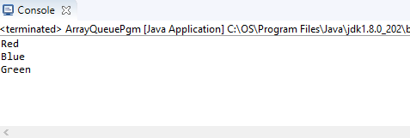

**HashSet**

**package** com.java;

**import** java.util.HashSet;

**import** java.util.Iterator;

**public** **class** HashSetPgm {

**public** **static** **void** main(String args[])

{

HashSet<String> set=**new** HashSet<String>();

set.add("Nayana");

set.add("Rohith");

set.add("Anoopa");

set.add("Nayana");

set.add("Jitty");

set.add("Anoopa");

set.add("Nayana");

Iterator<String> itr=set.iterator();

**while**(itr.hasNext())

{

System.***out***.println(itr.next());

}

}

}

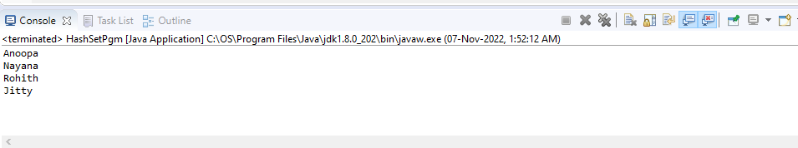

**LinkedHashSet**

**package** com.java;

**import** java.util.Iterator;

**import** java.util.LinkedHashSet;

**public** **class** LinkedHashSetPgm {

**public** **static** **void** main(String args[])

{

LinkedHashSet<String> set=**new** LinkedHashSet<String>();

set.add("Father");

set.add("Mother");

set.add("Father");

set.add("Sister");

Iterator<String> itr=set.iterator();

**while**(itr.hasNext())

{

System.***out***.println(itr.next());

}

}

}

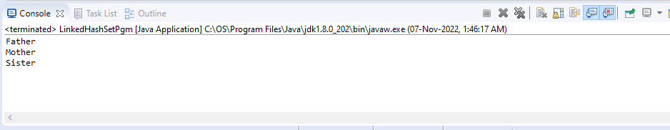

**TreeSet**

**package** com.java;

**import** java.util.Iterator;

**import** java.util.TreeSet;

**public** **class** TreeSetPgm {

**public** **static** **void** main(String args[])

{

TreeSet<String> set=**new** TreeSet<String>();

set.add("Father");

set.add("Mother");

set.add("Father");

set.add("Sister");

Iterator<String> itr=set.iterator();

**while**(itr.hasNext())

{

System.***out***.println(itr.next());

}

}

}

